RRI-LEADERS
Task 2.3 - discussion on task methodology MINUTES

Meeting participants:
- Zoya Damianova, Marko Hajdinjak, Desislava Asenova (ARC Fund)
- Snezhina Gabova (SDA)
- Yiannis Bakouros, Elpida Samaara (UoWM)
- Pavlos Kilintsiz (LGA-WM)
- Fridolin Brand, Richard Blaese (ZHAW)
- Benjamin Ueltschi (Municipality of Thalwil)
- Belen Lopez (FCRI)
- Sigrid Vedel Neuhaus, Julia Jakobsen (DBT)

Meeting is recorded with permission of participants.
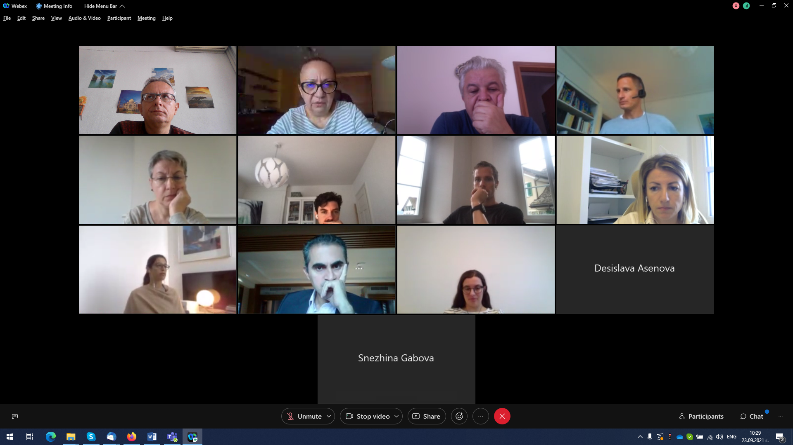

DISCUSSION
Zoya presents the draft methodology for Task 2.3 - RRI audits.
Zoya will send a draft content structure of the audit reports after the discussion and meeting today.
Yiannis: It is a straight-forward process, as long as we have finalised work in task 2.2. The policy developments are dynamic, so it is good that task 2.3 asks for revision and updating of our records and findings. There are some new elements and developments in our policy focus that we can incorporate and add to our previous analysis.
Zoya: When we start writing SWOT/TOWS analysis, we need to be very up-to-date regarding recent policy developments. We strongly encourage all partners to look into the new policy developments, not to copy/paste from previous deliverables.
Ben: It is not always clear from the Annual plan what is supposed to be done by territorial and methodology partners. Are the WP leaders going to tell who needs to do what?
Zoya: We will define the role of partners more precisely.
Elpida: Could ARC Fund provide some more specific comments on what to include in the audit reports in order to avoid repetition with T2.1 and T2.2?
Zoya: Go back to the original data for RRI and AIRR – the interviews’ summaries, the best practices, minutes from the participatory workshops, etc. – and critically re-assess the information. The data collected for two tasks is much richer than what was included in the two deliverables. Re-assess this data from the perspective of RRI and AIRR, because in D2.1 and D2.2, focus on RRI-AIRR was not always there, or was somewhat artificially added. In the previous two deliverables, the focus was much more on the chosen policy areas.
Snezhina: Sofia has 4 policy areas and we have already identified some policy options for the Delphi workshop. What should be the new information in this territorial audit report? In the interviews we conducted in task 2.1, there was not that much info about RRI-AIRR. How to obtain relevant information? What is the connection between policy objectives in task 2.3 and in Delphi? Can we use insight from Delphi for this report?
Zoya: Some policy objectives were identified for the initial draft of Delphi, but the Delphi process will start only in November.
Snezhina: How we produce an entirely new report focused on RRI and AIRR? Methodology asks for new people to be involved, but we have already identified most relevant experts for interviews and previous workshops. It would be beneficial to keep working with them, to deepen their knowledge of the project. With new people, much time will be needed to introduce them to what we have already done and we will not be able to obtain valuable and productive input. It will take more time. Can we have a mix group of new people that have already participated and new ones? Also, we will again be in election campaign in this period, which will interfere with the work.
Zoya: This is how it is in the GA and could not be changed. We need new people, otherwise we stay capsulated working with 25 people all the time. The idea is to have a broader basis of stakeholders who are engaged in this process. We need to find new people from Sofia. The focus group can be of 2.5 hours, this is why in the methodology it is foreseen that participants should receive 2-3 days prior to the meeting the draft report and for max half an hour this whole intro could be presented to the participants. It would be to send an information sheet of 2 pages prior the focus groups to the participants. The methodology as described in the GA is mandatory, and cannot be changed without amendment. For the RRI audit report – revisit and reassess the already collected information and obtain new one, including through few additional interviews and short online meetings, if necessary.
Yiannis: The outcomes of the analysis in task 2.2 will directly feed into 2.3. On our previous event, we always invited a mix of previous participant and new people, and we used previous participants as second-level moderators, they helped to introduce the new participants in the activities. In the mixed groups, we always had 8-10 newcomers, plus several participants from the previous events. If all are new, it is more difficult to involve them closely into the project.
Richard: For the focus groups we try to get new stakeholders. It is easier for some stakeholder groups to get engaged, like science and academia, but it is a bit critical for the group of policy makers. Can we go also to cantonal level, and not just municipal?
Zoya: Yes, you can go to the higher level.
Marko: A clarification on the participants: The participants will be different from the ones in the participatory workshop in Task 2.2, but some of them can be the same as in Task 2.1 (interviews and focus group).
Benjamin: It would be very helpful to get insight from policy-makers on the cantonal level.
Zoya: Yiannis, what is your advice and how we approach this at the level of the consortium? We need to follow a common approach to the focus groups and the recruitment of participants.
Yiannis: It is better to have a mixed group, 8-10 people is more than enough. We will go for online meetings, having in mind that in some case we might have in-person meetings. We will do our first with an in-person meeting in October in Greece.
Elpida: It would be beneficial to have participants from the national level also, not only local level.
Zoya: To sum up, participants in focus groups should be different from the ones in T2.2 which means that some participants from the interviews and the first FG could be involved (T2.1) but there should be also new participants. 8-10 participants per FG, at least 6-7 should be new so that we enlarge the stakeholder involvement to reach agreement on the transformative outlooks. Approach national level experts, not only local level.
All partners agreed it is an acceptable approach.
Zoya: In our next meeting it would be good that the territorial partners report on the number of stakeholders that have been involved in the project activities so far. It is important for the co-creation process. Partners should upload the stakeholder lists (of stakeholders involved in the project so far) to the cloud.
Yiannis: We already had 52 people involved in our activities. When we add 30 more for focus groups, we will reach the number of 80 involved stakeholders. There is a column in the Excel (List of Stakeholders) where we mark where the participants have participated, in which activity.
Elpida: We will upload our list of stakeholder participants and their involvement in different activities in the Next Cloud, for all partners to follow.

Other topics:
Missing information from deliverable 2.1 (stakeholder categorisation):
Elpida presents the excel table in which stakeholders and their knowledge/experience/influence regarding RRI keys and AIRR dimensions are marked.
Zoya: We had a similar table in the first version of D2.1 but we decided to remove it because it was criticised by Advisory Board that it was too optimistic – too many stakeholders were marked as having good knowledge and experience of RRI-AIRR, which is not realistic. We have to be very critical and look very carefully into our stakeholder’s profiles and reassess our categorisation. Very few are the ones who have experience, the second group. High levels of power are the policy makers.
Yiannis: In some case if it is not clear from the interview, we can follow up and call them on the phone. We will send the table to everyone.
Zoya: Please have a look at the original table from D2.1 first!
Frido: When this division would be finished so that we can use it for the Delphi?
Zoya: Territorial reports (drafts) should be ready by 25 November. The stakeholder table would be part of the territorial report.
Frido: That is too late for us, but we can work in parallel to select persons that have the power to influence the system elements; Delphi panels are mostly people with power, and some people with influence. For the Delphi we need the persons that have the interest and the power to influence. 18-20 experts per Delphi panel.
Zoya: For Sofia, 5 persons per area?
Frido: Not need to have 4 Delphi panels in Sofia. Go for 25-30 people and have more people per policy area. People with high interest and power in the policy area. Questions will be divided to policy areas, not all experts need to answer all questions in the questionnaire. Specific experts answer specific questions, not all. Participants will be provided with instructions about the Delphi prior the meetings.
Frido: We will provide the explanation of how to do this at the CM in the beginning of October. People involved in Delphi process will receive instructions in advance. Delphi panels should be selected by the end of October. The first Delphi questionnaire is a draft that will be tested in a pilot interview – after the pilots we will finalise the draft got the first Delphi round. By this Friday, Sept 24, we need to receive from all partners the draft questionnaires!
Snezhina: We need to align the FG schedules with the Delphi.
Frido: People need time to write down their opinions, these are specific questions. Preparation for the Delphi – they need to stay for three rounds, give them all information early on. An information sheet is not enough to make them stay, we need an individual approach to decrease the drop-out rate and keep the motivation – call them, get in touch with them. We will provide this package in the next week.
Elpida: Do we need to divide the questions per policy objectives?
Frido: Yes, Elpida, it is a good idea. You do not have to do it now but if you can do this by Friday, it is ok.
Yiannis: Can we add new good practices that came out recently and were not included in the first document we provided to ZHAW?
Frido: Absolutely – these documents can be updated at any time before starting the Delphi rounds.
Snezhina: Some deadlines and activities from annual plan have changed. Can we receive an update for the remaining period, until December 31?
Zoya: Ok, we will send an updated version of the time table.
Elpida: Wil we have individual meeting regarding semestrial reporting
Zoya: We have a regular monthly meeting on October 5, and after October 5 we will organise the individual meetings. Please let me know about the appropriate time for you to schedule the meetings – send me e-mails. If there are no further questions and comments, I will go through the methodology, finalise it and sent it to all partners.

Next meeting – 5 October.
Please provide comments on the methodology by end of business on 28 September (Tuesday) at the latest, so that the final version of methodology is distributed by September 30.

